**Preprint citation – The Biologist**

Since 1991, the arXiv has been heralded as the pinnacle of community-led scholarly communication. The arXiv was developed as a centralised storage platform for physicists, mathematicians, computer scientists, and related disciplines to share the results of their research freely and rapidly with the rest of their research community. In fact, this is exactly the reason why the Web was originally developed at CERN just a couple of years prior!

These days, arXiv receives more than 8000 article submissions a month, and [4 of the most highly cited ‘journals’ are sub-sections of the arXiv](https://scholar.google.com/citations?view_op=top_venues&hl=en&vq=phy). No matter how you look at it, in terms of the mission of the arXiv, it has been a roaring success.

In the last 2-3 years, the life sciences seem to have cottoned on to this, and many are now pushing for wider adoption of preprints. Several developments seem to have been the catalyst for this, including the development of [biorXiv](http://biorxiv.org/), the [ASAPbio initiative](http://asapbio.org/), and high-level policy changes such as the [NIH now allowing preprints in grant submissions](https://grants.nih.gov/grants/guide/notice-files/NOT-OD-17-050.html). The result of this has been exceptionally rapid growth of preprints in the life sciences, now reaching the 1000/month mark.

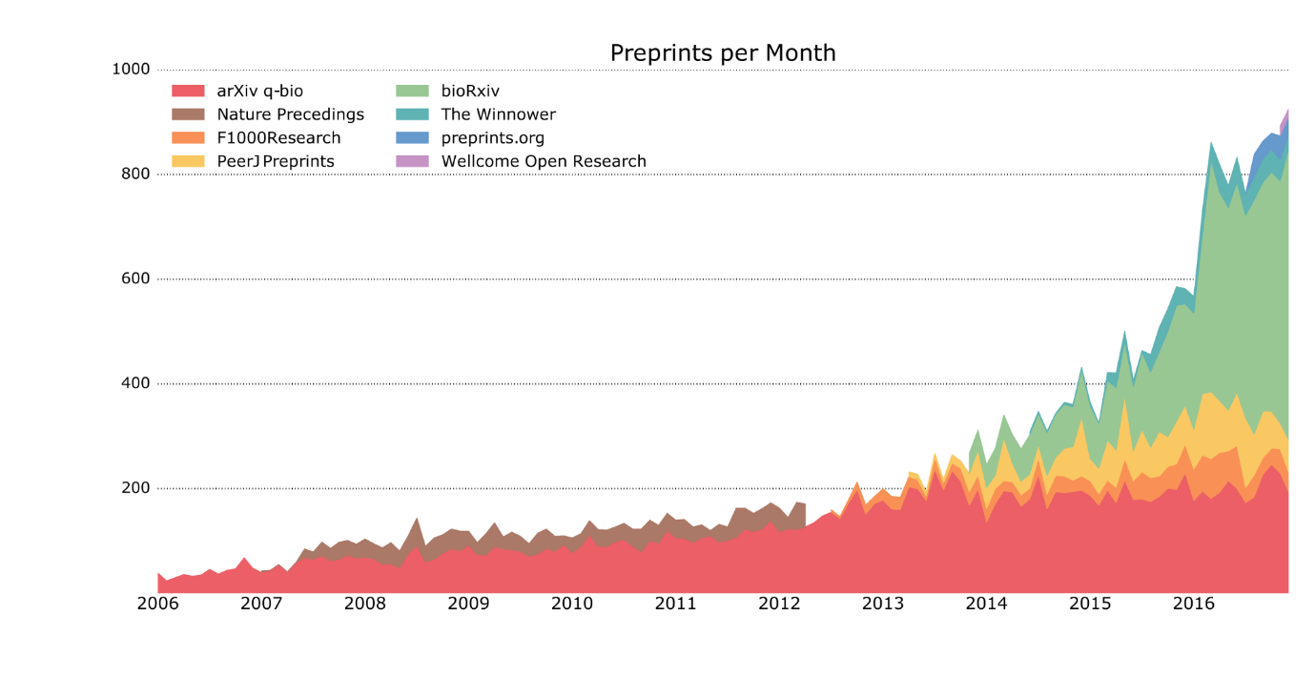

Figure : Source data, PrePubMed, courtesy of Jordan Anaya ([source](https://medium.com/@OmnesRes/a-journal-reveals-its-true-colors-f1bd9027c008))

In spite of this, there seems to be a fair amount of resistance across the extremely heterogeneous ‘life sciences’ domain. In particular, some researchers are claiming that preprint citation constitutes bad scholarship, and that publishing preprints is no different to publishing other ‘grey literature’ like blog posts. I recently established [paleorXiv](http://fossilsandshit.com/paleorxiv/) for my research field, and a personal email from a senior researcher emphasised fears that it might be used by creationists to ‘get one over’ on real science. Yikes!

To understand this, we have to really think about the philosophy behind preprints, any why there seems to be so much resistance from different sectors of the community. One big aspect of this is that new means doing things different. Researchers don’t get incentivised for doing things differently, though – we get rewarded for following the straight and narrow, staying within the system boundaries, and playing the game. In this system, all the rules are set by those higher up, and not those who want to experiment and research new ways of doing things. If anyone has ever heard the term ‘publish or perish’, this is basically the slogan for the academic system.

Preprints represent a completely new way of communicating scholarship, and one which totally flips the traditional way of doing things on its head. For the last 50 years, we have published 100 million research papers where the process has always been the same: ‘filter then publish’, with peer review and journal selectivity defining the filters. With preprints, this inverts the process to become one where we ‘publish then filter’. Except now, both are community-led processes, and that means the responsibility to engage with and moderate the process is largely on researchers themselves. This means that academics become more accountable for the process, and thereby any risks or problems are inherently perceived as negative when compared to the traditional model, rather than as simple by-products of any innovative system. Often, this leads to a state of ‘cultural inertia’, rather than one where we constructively debate issues to work towards solutions.

And this is totally okay, because change always occurs at different paces. Ideas in our head advance faster than technology; technology advances faster than individual practices; and those practices advance faster than widespread cultural changes. So preprint resistance is less to do with technology, and more to do with overcoming social barriers.

At the moment, preprints and their usage are somewhere in the ‘technology and ideology’ stage, as a combination of new platforms and new ideas spring about in the life sciences. To move things further and faster, those who are leading this need to make sure that we are engaging different communities in the development, especially those who might not agree with us. We get stronger as a community by embracing different viewpoints and using them to develop constructively.

The result of this is that resistance often becomes completely understandable, but rarely justifiable once potential issues have been openly discussed. For paleorXiv, we decided to create a set of community-oriented [submission guidelines](http://fossilsandshit.com/paleorxiv/submission-guidelines-authors/) that addressed the concerns of the community, and particularly reagrding preprint citations. To me, the most important is “Please exercise the same care and judgment you would use for any research output when it comes to the citation and re-use of preprints”. In other words, do your job as a scholar properly.

So when someone says “I don’t cite preprints”, ask them “Why?”, instead of ignoring or belittling them for it, and use this to work constructively towards a solution that works for everyone. That’s how we all progress.